Multi-tape Turing Machines have multiple tapes where each tape is accessed with a separate head. Each head can move independently of the other heads. Initially the input is on tape 1 and others are blank. At first, the first tape is occupied by the input and the other tapes are kept blank. Next, the machine reads consecutive symbols under its heads and the TM prints a symbol on each tape and moves its heads.

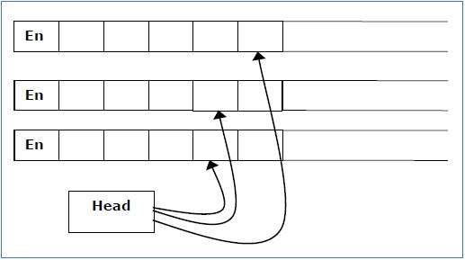

A Multi-tape Turing machine can be formally described as a 6-tuple (Q, X, B, δ, q0, F) where −

* **Q** is a finite set of states
* **X** is the tape alphabet
* **B** is the blank symbol
* **δ** is a relation on states and symbols where

δ: Q × Xk → Q × (X × {Left_shift, Right_shift, No_shift })k

where there is **k** number of tapes

* **q0** is the initial state
* **F** is the set of final states

**Note** − Every Multi-tape Turing machine has an equivalent single-tape Turing machine.